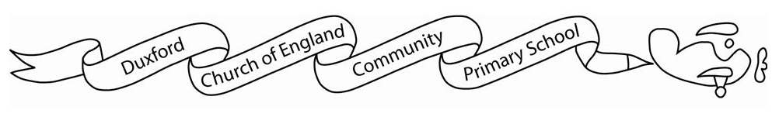
Starling class Curriculum Grid:
 | Summer 1 | Summer 2
English | Text: Rapunzel by Bethan Woollvin | To be confirmed
Maths | Year 1 and 2  Statistics  Measurement  Money  Number  Fractions | Year 1 and 2  Measurement  Time  Measurement  Mass Capacity and temperature  Geometry  Position and direction
History |  | Flight and transport
Geography | What can you see at the coast?
Music |  | Dance, sing and play
Art / DT | Printing | Textiles
RE | Why is the Torah such a joy for the Jewish community? | What is the good news that Jesus brings?
PE | Athletics | Trails, Trust and Teamwork
PSHE | Healthy & Safer Lifestyles. Relationships and Sex Education | Working together
Computing | Using and applying
Science  (YR2) | Humans (lifestyles) | Scientists and inventors
Science  (YR1) | Humans | Scientists and inventors

