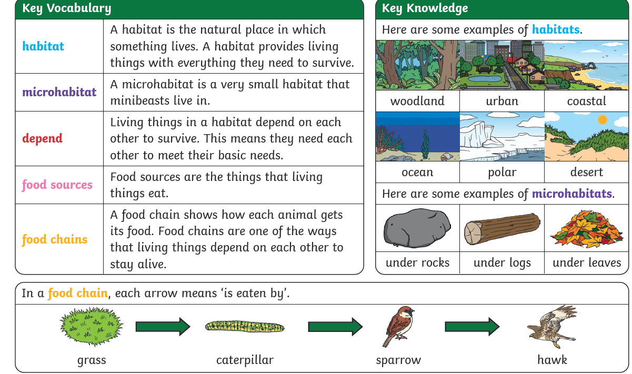
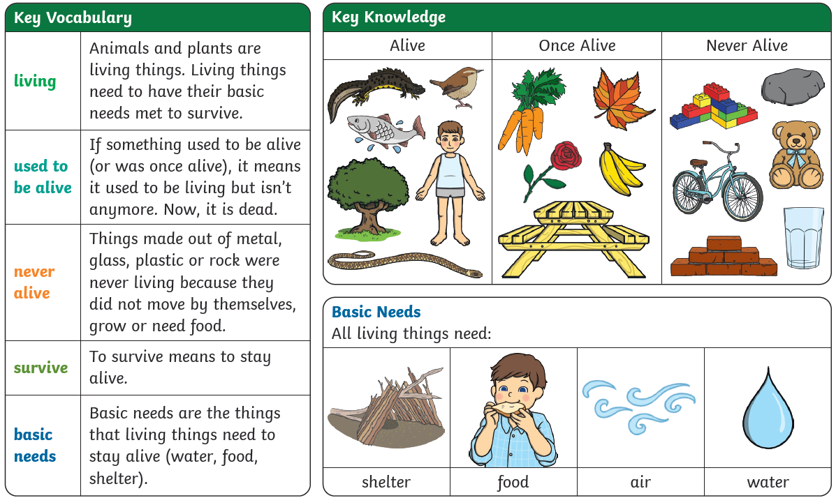

L1- Is it alive?
L2- what habitat can I find near me?
L3- What are microhabitats?
L4 - Are there the same minibeasts in different microhabitats
L5-How do animals and plants in world habitat depend on each other?
L6- How does a food chain explain how animals get their food?

