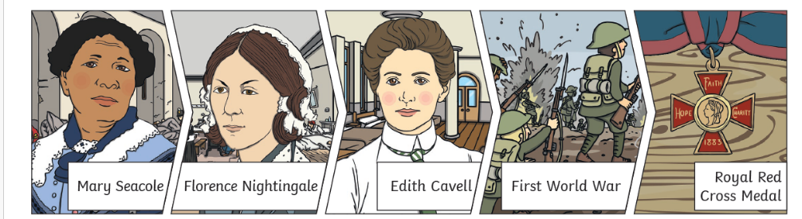
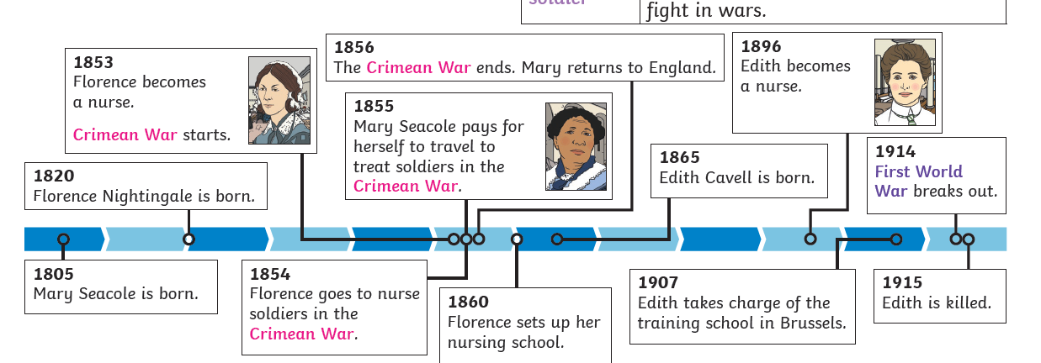

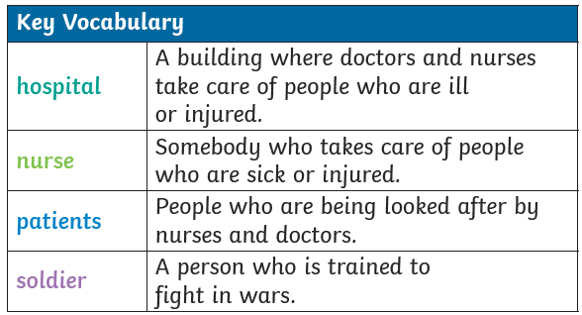

What were Nurses like in the past
L1  LO: What makes a person significant? | A significant person is some one who  - Changed events at the time they lived.  - Improved lots of people’s lives or made them worse.  - Changed people’s ideas.  - Had a long lasting impact on their country or the world.  - Had been a really good or very bad example to other people on how to live or behave.
L2  LO: How did Florence Nightingale improve nursing? | Florence Nightingale was a nurse. She made hospitals cleaner for patients and looked after soldiers in the Crimean War. She set up the Nightingale Training School for nurses in 1860.
L3  LO: Who was Mary Seacole and how did she improve nursing? | Mary Seacole was a nurse. Her mother was Jamaican and her father was Scottish. She travelled from Jamaica to look after wounded soldiers on the battlefield in the Crimean War. She set up a hospital called the British Hotel to look after soldiers.
L4  LO: Who was Edith Cavell and how did she improve nursing? | Edith Cavell was a nurse in the First World War. She saved soldiers from both sides during the First World War. Edith helped over 200 soldiers escape from the German army.

