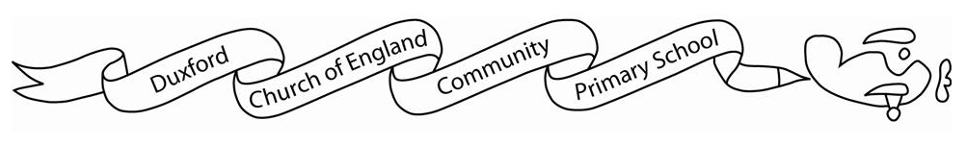
Home learning Spring 2

It is expected that the following home learning will be completed each week:

Reading: Please listen to your child read using the Rhino reader guidance attached. Books are changed every Monday. Please note that we only change books once children can read them fluently (without sounding out). Please write in your child’s reading record if they are reding fluently or are still sounding out.

Maths:
Year one children can use the following websites to support their maths knowledge.
https://www.bbc.co.uk/bitesize/articles/zf4sscw
https://www.topmarks.co.uk/maths-games/5-7-years/counting
https://www.bbc.co.uk/bitesize/topics/zjkphbk/articles/zd4b382
https://home.oxfordowl.co.uk/kids-activities/fun-maths-games-and-activities/

Year two children are expected to access Timetables Rockstars for 30 minutes a week. There are also learning resources for a variety of subjects on Starz if you wish to do some additional work with your child/ children.

The History home learning below is optional:
In History this half term we will be learning about the Significant figures in Nursing. Your challenge is to create a collage portrait of a significant historical nurse, Florence Nightingale or Mary Seacole. Please bring your projects in on the week before half term.

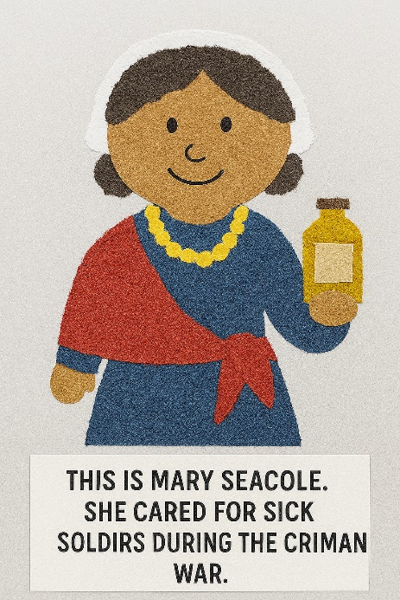
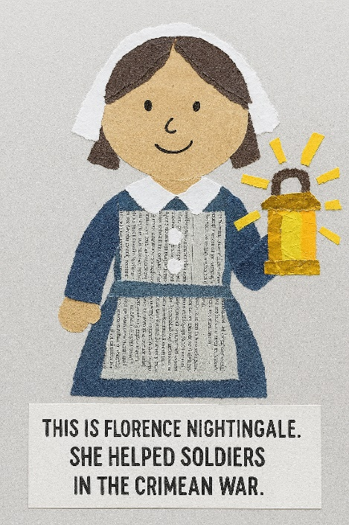
See the example below:

What You Need
l Scrap paper (magazines, newspapers, leaflets, coloured paper)
l Glue stick
l Scissors (or children can tear by hand)
l Pencil
l Optional: tissue paper, tin foil, fabric scraps, string
Step-by-step Instructions
1.Choose Florence Nightingale or Mary Seacole. Talk about what they wore, the objects they used (lamp or medicine bottle), and how they helped people.
2. Draw a Simple Outline: On plain paper, draw a large simple outline: head, body, clothes, and an important object (lamp or bottle).
3. Collect and Prepare Collage Materials: Tear or cut pieces of paper. Sort by colour/pattern. Choose yellow/gold for a lamp, bright patterns for Mary Seacole’s dress, blues/whites for Florence’s uniform.
4. Fill the Outline with Collage: Stick big shapes first, then smaller ones. Overlap and layer for texture. Use darker paper for hair; patterned paper for clothing.
5.When dry, draw facial features and details such as buttons, bonnet, necklace, lamp light or a label on the bottle.
6. Add a Caption. Write one sentence under the artwork—e.g., ‘This is Florence Nightingale. She helped soldiers in the Crimean War.’ or ‘This is Mary Seacole. She cared for sick soldiers at the British Hotel.’

