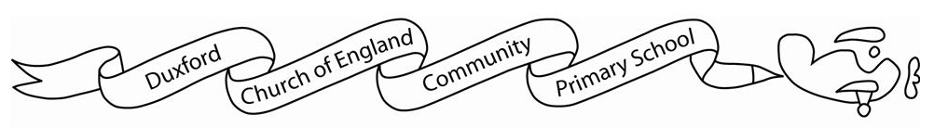
Home learning Autumn 2

It is expected that the following home learning will be completed each week:

Reading:
Children are expected to read at home. Books are available to borrow from the classroom library. Reading aloud to an adult is strongly encouraged.

Spelling:
Children can access and practise their spellings on Spelling Shed.

Maths:
Children are expected to access Timetables Rockstars for 30 minutes a week.

Additional resources:
There are lots of additional resources and websites that you can access on Starz which will support your child’s learning.

The Science home learning below is optional:

This term I would like students to research an endangered animal and produce a fact file about them to go outside our classroom! You might include information about the animal’s scientific name, features, habitat, and a sketch or picture!

Species suggestions:

The Pangolin
The Amazonian Manatee
The Green seat turtle

Useful websites:

National Geographic/ NatGeoKids
World Wildlife Fund
IUCN red list

