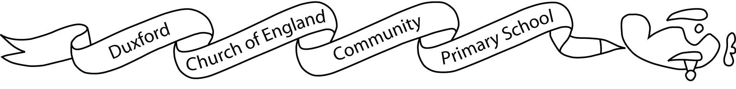
Aim High, Fly High
Friday, 21st April 2023
Dear Parents
It has been a brilliant few days back – all the Finches have been full of enthusiasm and gusto! I have particularly been impressed with how well they have played together at break times.
This half term we will have Miss Samuelson working alongside myself and Mrs Kaye; having an extra adult will allow us to do some targeted teaching which will be a huge benefit to the children.
Our History focus this half term is The Great Fire of London. Attached is our Knowledge Organiser which shows what Finches will be learning. I have also attached the curriculum overview of this term and this half term’s homework. Please note that the Topic homework is not compulsory but the Reading, spellings and Times tables are. The spellings will appear on Starz each week as from Friday, 28th April. I would also like to remind you that reading books can be changed on Thursdays; however, please could the children have their reading books and logs in their bags every day. Reading for pleasure books can be changed at any time.
PE days are still Mondays and Wednesdays so children can come to school in their PE kits on those days. Please can they still bring coats into school. They go out to play even if it raining so it is important they can stay dry. Also, their Outdoor Learning sessions are on a Wednesday and the children will need long trousers and long sleeved tops; this is to avoid getting stung by nettles or scratched. Without the correct clothing, they will not be able to join in.
And finally, if you have any questions or concerns, please do not hesitate to contact me via the office. I am always happy to chat over the phone, on Teams or in person.
Kind regards
Mrs Lee Frere

