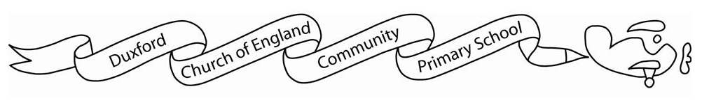?
Robin class Curriculum Grid:
 | Summer 1 | Summer 2
English | Text: Jack and the Beanstalk  Text: Everybody Has a Body  Text: You’re so Amazing  Text: I Don’t Want to Wash My Hands | Text: Here I Am  Text: Super Joe Does Not Do Cuddles  Text: Belonging Street
Maths | Reception:  Numbers within 10:  -Subitising  -One more and one less  -Doubling  3D shapes  Numbers within 20:  -building numbers  - counting  - patterns  Addition and subtraction  Year 1:  Multiplication and division:  -counting in 2s, 5s and 10s  - making equal groups  -doubling  -making arrays  Fractions:  -finding half of a shape, object or amount  - finding a quarter or a shape, object or amount | Reception:  Manipulating, composing and decomposing shapes  Sharing and grouping  Visualising, building and mapping  Year 1:  Geometry- position and direction  Place value within 100:  - Counting withing 100  - 1 more and 1 less  - tens and ones  - comparing numbers  Money  Time:  - days of the week  - months of the year  - hours, minutes and seconds  - O’clock  - half past
Geography | What is it like by the coast?
History |  | How has flight and transport changed?
Art / DT | 3D art- printing | Textiles
RE | What is the story of Easter | How should we care for ourselves and for others, and why does it matter?
PE | Athletics | Trails, trust and teamwork
PSHE | My body and growing up (Relationships and Sex education) | Healthy lifestyles
Computing  (YR1) | N/A | Data and information
Science  (YR1 only) | Humans | Scientists and inventors

