Key Vocabulary
London | The capital city of England and the UK where the Gunpowder Plot  took place.
plot | A secret plan to do something that could hurt others or is not allowed.
gunpowder | A powder used to create explosions.
Catholic | A Christian who is a member of the Catholic Church.
Protestant | A Christian who is a member of the Church of England.
Guy Fawkes | A gunpowder expert who was blamed for the plot.
King James I | The king of England when the Gunpowder Plot took place.
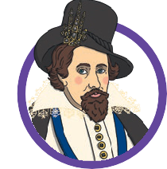
King James I
Thomas Percy
Robert Catesby
Guy Fawkes
Key People
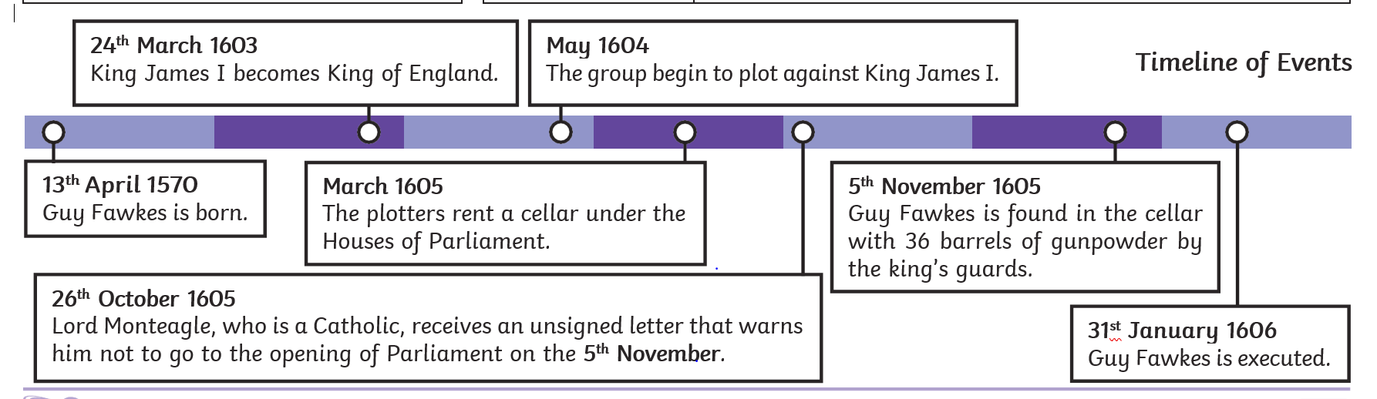

Key knowledge:
L1- What would Guy Fawkes have used in 1605? | In 1605 they used items including a quill and ink, lanterns, gunpowder barrels and pocket watches.
L2- How did the Gunpowder Plot start? | King James I was punishing the Catholics. A group of young Catholic men wanted to stop King James I by blowing up the Houses of Parliament.  The plotters were all Catholic. They thought that King James I was being unfair to Catholics because he was a Protestant. They did not want him to be the king any more.
L3- What were the key events of the Gunpowder Plot? | A group of Catholic men planned to blow up the houses of parliament.  They hid gunpowder under the houses of parliament.  Someone warned the government and Guy Fawkes and the plotters were caught.
L4- What happened to the plotters after the plot was discovered? | Someone warned the government warned and Guy Fawkes was caught in the cellar.  Thomas Percy was found on 8th November 1605. He was hiding with some of the other plotters, including the leader Robert Catesby. In the battle that followed, both Thomas Percy and Robert Catesby were killed. The other plotters were captured.
L5- What happened in the Gunpowder Plot? | King James I was punishing the Catholics.  Robert Catesby got some Catholic men together.  They hid gunpowder under the houses of parliament.  Someone warned the government and Guy Fawkes and the plotters were caught.
L6- How is the Gunpowder Plot remembered? | Remember, remember the fifth of November  gunpowder, treason and plot.  I see no reason, why gunpowder treason  Should ever be forgot.

