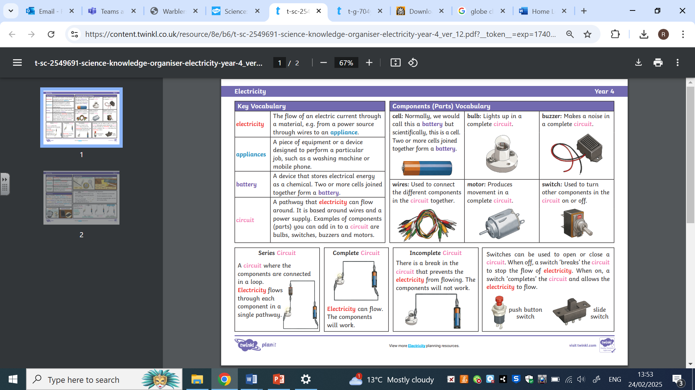
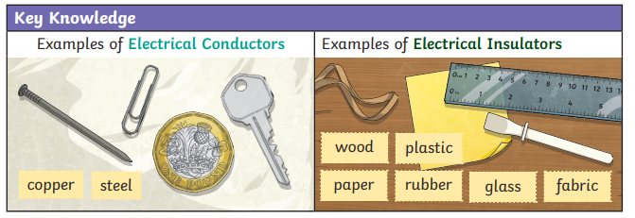
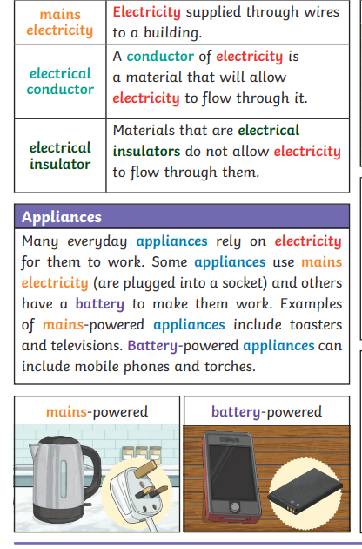
Learning Objectives
1 | To understand electrical appliances.
2 | To learn how to make a circuit.
3 | To identify what makes a complete circuit.
4 | To identify electrical insulators and conductors.
5 | To explain how a switch works in a circuit.
6 | To discuss and solve problems about electricity using reasoning skills.

