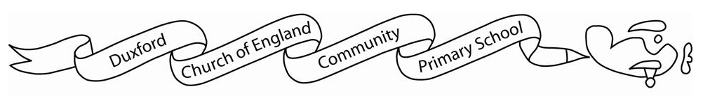
Home learning Autumn 2

It is expected that the following home learning will be completed each week:

Reading: Please listen to your child read using the Rhino reader guidance attached. Books are changed every Friday. Please note that we only change books once children can read them fluently (without sounding out). Please write in your child’s reading record if they are reding fluently or are still sounding out.

Maths:
Yr1 children can use the following websites to support their maths knowledge.
https://www.bbc.co.uk/bitesize/articles/zf4sscw
https://www.topmarks.co.uk/maths-games/5-7-years/counting
https://www.bbc.co.uk/bitesize/topics/zjkphbk/articles/zd4b382
https://home.oxfordowl.co.uk/kids-activities/fun-maths-games-and-activities/

The History home learning below is optional:
In History this half term we will be learning about The Gunpowder plot and Guy Fawkes . Your challenge is to make a ‘wanted poster’ for Guy Fawkes
Some examples are below:
