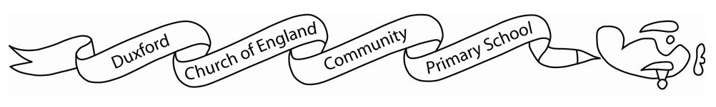

**Owls class Curriculum Grid:**

|  |  |  |
| --- | --- | --- |
|  | Spring 1 | Spring 2 |
| English | Text: Incredible Jobs You’ve Probably Never Heard of by Natalie Labarre  Text: Alice’s Adventures in Wonderland | Text:  Text: |
| Maths | *Year 2:*  Multiplication and Division  Money  *Year 3:*  Multiplication and Division  Money  Length and Perimeter | *Year 2:*  Length and Height  Mass, Capacity and Temperature  *Year 3:*  Length and Perimeter (continued)  Mass and Capacity |
| History | Ancient Egyptians;  ‘What did the Ancient Egyptians believe?’ |  |
| Geography |  | All Around the World |
| Science | *Year 2:*  Living things and their habitats  *Year 3:*  Rocks | *Year 2:*  Plants  *Year 3:*  Plants |
| Art / DT | Drawing | Structures |
| Computing | Digital Media: Photography | Programming |
| PE | Gymnastics | Invasion Games |
| PSHE | Personal Safety | Managing Safety and Risk |
| RE | Why do Hindus want to collect good karma? | When Jesus left, what was the impact of Pentecost? |
| Music | Production practice | The Dragon Song |
| French  (Year 3) | French Playground games – numbers and age | In a French Classroom |