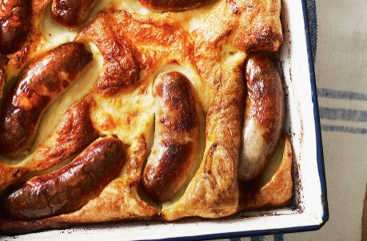
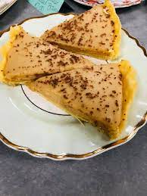
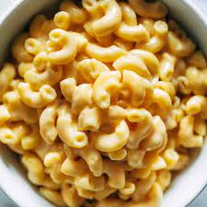
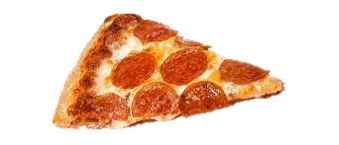
Monday | Tuesday | Wednesday | Thursday | Friday
Mac ‘n’ Cheese  Garlic bread | Chicken Curry  Fluffy rice  Naan bread | Cottage Pie  Seasonal vegetables | Hot sausage roll  Crispy potatoes  Beans | Battered fish  Chips  Garden peas
 | Quorn Curry  Fluffy rice  Naan bread | Quorn Cottage Pie  Seasonal vegetables | Hot vegetarian sausage roll  Crispy potatoes  Beans | Quorn dippers  Chips  Garden Peas
Tuna mayo pasta side salad | Tomato and basil pasta | Chicken and sweetcorn pasta side salad | Sausage and tomato pasta side salad | Cheesy pasta and salad
Filled roll with Ham, side salad and tortilla chips | Filled roll with chicken mayo, side salad and tortilla chips | Filled roll with cheese side salad and tortilla chips | Filled roll with ham , side salad and tortilla chips | Filled roll with cheese, side salad and tortilla chips
Ginger biscuit  Fresh Fruit  Yogurts | Fudge tart  Fresh fruit  Cheese and crackers | Pineapple muffin  Fresh fruit  Yogurts | flapjack  Fresh fruit  cheese and crackers | Waffle with sauce  Fresh fruit  Yogurts
Monday | Tuesday | Wednesday | Thursday | Friday
Meatballs in tomato sauce with pasta  Seasonal vegetables | Sausage  Mash  Seasonal Vegetables | Hotpot  Seasonal vegetables | Chicken bites  Crispy potatoes  Baked Beans | Breaded fish  Chips  Garden peas
Quorn in tomato sauce with pasta seasonal vegetables | Vegetarian sausage  Mash  Seasonal Vegetables | Vegetable Hotpot  Seasonal vegetables | Quorn dippers  crispy potatoes  Baked Beans | Vegetable Fingers  Chips  Garden Peas
Baked potato with tuna mayo  Salad | Baked potato with cheese and beans  Salad | Baked potato with ham and coleslaw  Salad | Baked potato with cheese  Salad | Baked potato with tuna  Salad
Filled roll with tuna, side salad and tortilla chips | Filled roll with ham, side salad and tortilla chips | Filled roll with cheese, side salad and tortilla chips | Filled roll with ham, side salad and tortilla chips | Filled roll with cheese, side salad and tortilla chips
shortbread  Fresh Fruit  Yogurts | Chocolate brownie  Fresh fruit  Cheese and crackers | Apple crumble and custard  Fresh fruit  Yogurts | Flapjack  Fresh fruit  cheese and crackers | Mixed doughnuts  Fresh fruit  Yogurts
