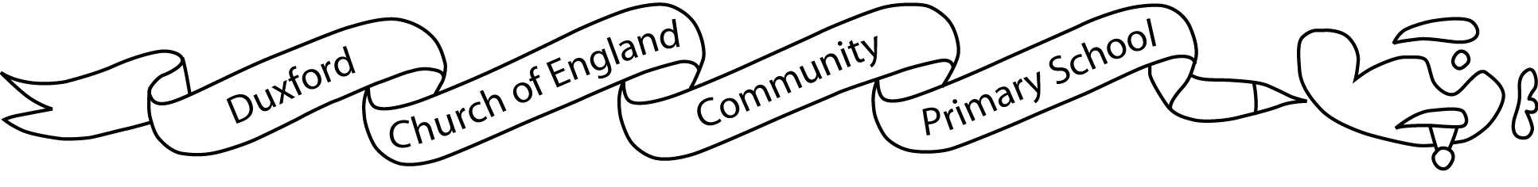

Aim High, Fly High

Dear Parents/ Carers,

I hope you’ve all had a lovely Summer holidays and are ready to start a new fabulous year! I’ve got a lot of brilliant things planned for Warblers class this term and I am eager to get started.

In Warblers class this term we will still be practicing our spellings, handwriting and times tables for our start of the day activity. As I’m sure you are aware, these are important requirements for every child’s learning- please ensure your child arrives in school on time so as not to miss anything.

We have a very exciting Autumn term ahead of us in which we will be looking at topics such as:  The Anglo Saxons (History) and ways of working with Textiles (Art). We’ll be studying how to write a persuasive speech in English. If you would like more information on what else we will be learning about in the Autumn term, please refer to the Curriculum Map provided.

This term’s PE lessons will be on Wednesdays and Fridays. Please ensure your child comes to school already wearing appropriate PE kit (school PE T-shirt with logo on or plain white/black/navy t-shirt, joggers or shorts, trainers and normal school jumper). Likewise, students should bring weather-appropriate covering clothes for Forest School (e.g. a long-sleeved shirt, long trousers/ jogpants if wearing shorts) on Wednesdays for safety purposes. Please ensure all uniform and removable clothing is named to avoid confusion and/ or loss of property.

Children are welcome to bring a fruit or vegetable snack to consume during morning break time, and are encouraged to have a named water bottle for the whole day. It is also recommended that students have their own supplies for use in lessons such as a small, clear pencil case and a small set of coloured pencils, to be kept in trays.

**Optional** homework can be found in the Home Learning grid labelled as such and included with this letter. **Mandatory** homework is to practice on Spelling Shed and Times Table Rockstars a minimum of three times a week. Please encourage your children to access these websites as much as possible. Year Fours have the Government mandated times tables test at the end of the school year so it is especially important for them to get as much practice as possible.

I hope that we can work together to have a wonderful term!

Best wishes,

Mrs R. Yeo

Warblers Class teacher.