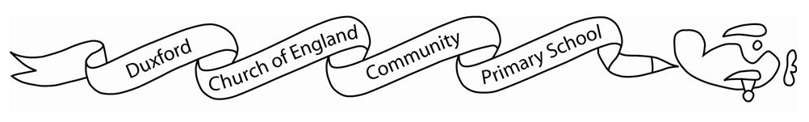

**Home learning Spring 1**

It is *expected* that the following home learning will be completed each week:

**Reading:** Please listen to your child read using the Rhino reader guidance you were provided last term.  Books are changed every Friday. Please note that we only change books once children can read them fluently (without sounding out). Please write in your child’s reading record if they are reading fluently or are still sounding out. For Year 3 children, we expect them to read for at least 30 minutes a week.

**Maths:**

Children are expected to access Times tables Rockstars for 30 minutes a week.

**Additional resources:**

If you would like further additional resources to support your children at home, then please contact me through the office.

**The Topic home learning below is optional:**

In Topic, this half term we will be learning about the Ancient Egyptians and what they believed in. Children can find and research about one element of the Ancient Egyptians that they enjoy and create a piece of work (this could be art, a poster etc.).