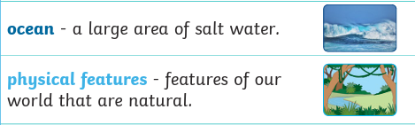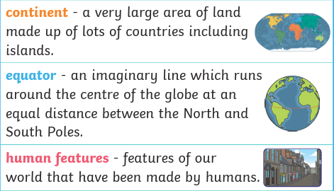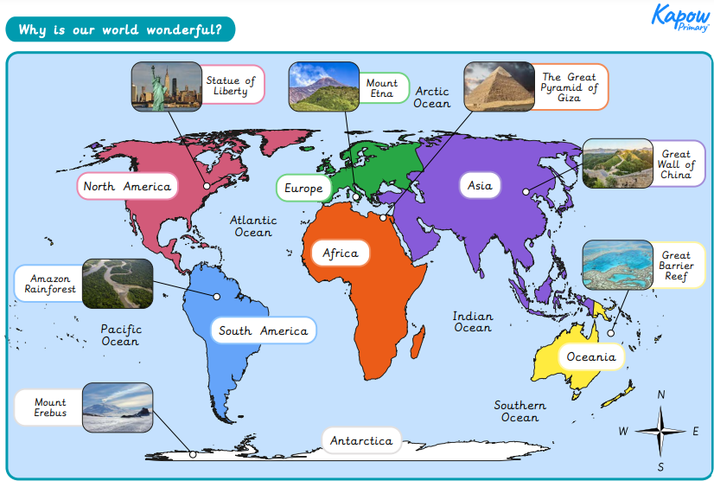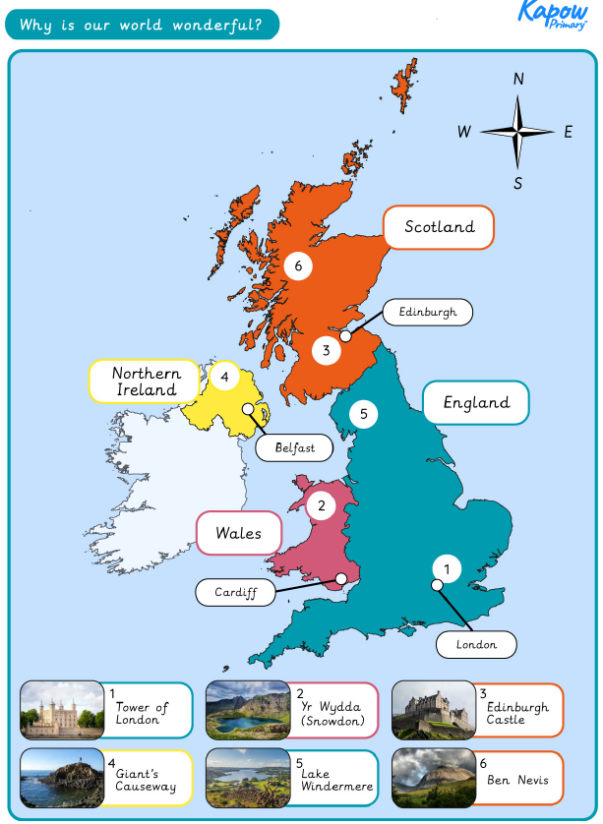

Key vocabulary:

|  |  |
| --- | --- |
| L1- LO: What are some of the UKs human and physical features? | Identify and locate characteristics of the UK on a map.  Some features on a human (made by people), for example, The Tower of London. Some features are physical (naturally made), for example, The Giants causeway. |
| L2- LO: Where are some of the world’s most amazing places? | The world has some amazing places. For example, the Great Pyramid of Giza and the Amazon River. |
| L3- LO: Where are our oceans? | There are five oceans in the world. Atlantic Ocean, Pacific Ocean, Indian Ocean, Artic Ocean and Southern Ocean. |
| L4- LO: Which parts of the world have hot and cold climates? | The hot and cold areas of the world are in relation to the equator and the North and South poles. Countries closer to the equator have hotter climates. |
| L5- LO: What human and physical features are in our local area? | Understand how to draw human and physical features on a sketch map |