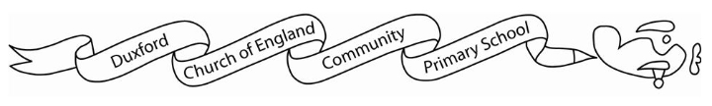
Home learning Summer 1

It is expected that the following home learning will be completed each week:

Reading: Please listen to your child read using the Rhino reader guidance attached. Books are changed every Friday. Please note that we only change books once children can read them fluently (without sounding out). Please write in your child’s reading record if they are reading fluently or are still sounding out.

Maths:
We no longer have numbots but children can use the following websites to support their maths knowledge.
https://www.bbc.co.uk/bitesize/articles/zf4sscw
https://www.topmarks.co.uk/maths-games/5-7-years/counting
https://www.bbc.co.uk/bitesize/topics/zjkphbk/articles/zd4b382
https://home.oxfordowl.co.uk/kids-activities/fun-maths-games-and-activities/

Additional resources:
There are lots of additional resources and websites for you to access on Starz which will support your children’s learning.

The Geography home learning below is optional:

1. Seaside Scavenger Hunt
Task: Go on a walk (or imagine one!) and find seaside items.
Ideas to find/draw: shells, pebbles, seaweed, birds, boats
Challenge:
- Draw and label what you find
- Sort items into natural and man-made

2. Make a Coastal Collage
Task: Create a seaside picture using materials (paper, sand, shells, etc.)
Challenge:
- Include sea, beach, and sky
- Label features like “sea”, “sand”, “cliff”

3. Sea Creature Fact File
Task: Choose a sea animal (e.g. crab, fish, dolphin)
Include:
- What it looks like
- Where it lives
- What it eats
Challenge: Write 3-5 simple sentences

