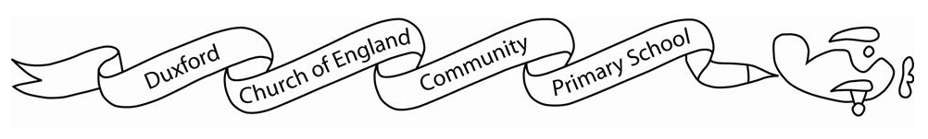

**Home learning Spring 2**

It is *expected* that the following home learning will be completed each week:

**Reading:** Please listen to your child read using the Rhino reader guidance attached. Books are changed every Friday. Please note that we only change books once children can read them fluently (without sounding out). Please write in your child’s reading record if they are reding fluently or are still sounding out.

**Maths:**

**Yr1** Children are expected to access Numbots for 30 minutes a week.

**Additional resources:**

There are lots of additional resources and websites for you to access on Starz which will support your children’s learning.



**The Geography home learning below is optional:**

In Geography our unit is ‘Our wonderful world’.

We will be learning about the oceans and continents.

Your challenge is to make your own papier mâché globe.

There are instructions below to help you.

Please bring your home learning in on the last week of half term for

everyone to see.

