Duxford Church of England Community Primary School
PARENT HANDBOOK
2025/2026

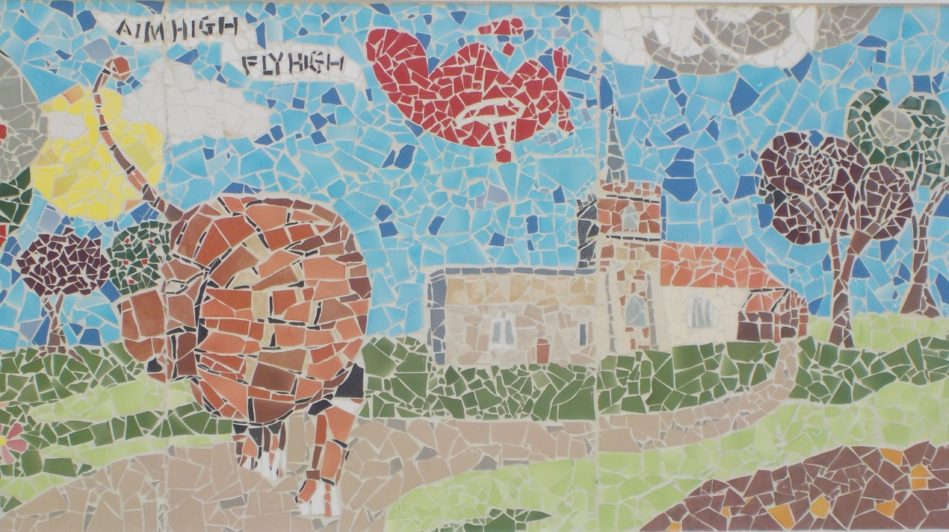

Contents page
Aims and Values 3
Welcome to Duxford Primary School 4
Welcome to Reception 7
Enjoying books at home and at school 10
Assemblies 11
School Clothing and Property 12
Child Welfare 14
Attendance 16
National Curriculum 17
The FODs 18
The Governing Body 19
Extra Curriculum Activities 19 Breakfast and DX After School Club 19
Music Tuition 20
Music Workshop 20
Active Travel 21
Staff 22
Education Jargon Buster 23
Contact Information 24

Aims and values of Duxford (C of E) community primary school
Mission statement
To nurture our children, within a Christian setting, to reach their potential and grow into balanced, thriving individuals.
Vision
Our vision as a Church School is to provide high quality, inclusive education in a safe, nurturing and supportive Christian environment where we ‘Encourage one another and build up one another’ 1 Thessalonians 5:11. We inspire our children to learn as much as possible and achieve their individual potential whilst developing confidence, respect and consideration for others. We seek to equip our children with the knowledge, skills and personal attributes to take advantage of opportunities and rise to the challenges which their future may present.
Values
A Attentive
I Imaginative
M Motivated
S Spiritual

Attentive to ourselves, to those around us and to our environment. We nurture and respect one another, recognise each other's uniqueness and ensure we value individuals, relationships and our environment.
Imaginative and respondent to a broad and balanced curriculum that offers memorable experiences to inspire the mind. We believe a rich and varied curriculum helps to enthrall learners to be creative, independent thinkers; able to solve problems in the rapidly changing society in which we live.
Motivated for academic excellence and a life-long love of learning. By developing a strong growth mindset, including resilience and perseverance, we can respond flexibly and question the world and those around us. This allows us to challenge ourselves to be the best that we can be. We encourage our children to be courageous advocates.
Spiritual awareness and growth in an ethos underpinned by Christian values, supports wellbeing. We value this within our school, our families and within our wider community.

WELCOME TO DUXFORD SCHOOL
There is a huge amount of information to take in when your child starts a new school, particularly if this is your eldest child and their first experience of school. This might be the first time that you have been back to a primary school since leaving your own! You will find that lots of things have changed and we hope this booklet will go some way towards explaining some of these changes. This guide is produced to answer some commonly asked questions that may not have been answered in the school’s official documentation, to talk about school routines and give practical guidance.
We are confident that your child will flourish and enjoy their time at Duxford School.

GENERAL LIFE AT DUXFORD SCHOOL
When does school start and finish?
The school day starts at 8.50am. The school gates open at 8.40am and children should go straight to their classroom’s external door. Lunchtime is between 12.05pm and 12.55pm. All children have a 15 minute break in the morning. School finishes at 3.20pm. An on-site breakfast club is available from 7.45am and an after-school club is available until 6pm. More details are available through the school office.

What are school dinners like?
School meals are popular and are cooked by our own in-house catering team in the school kitchen. Lunch consists of a two-course meal, offering a choice of main courses, vegetables, salads and dessert. The menus are designed to be tempting and healthy and offer choice for vegetarians, with some special diets available. Children may choose each day whether to opt for a school meal or bring a healthy packed lunch if they prefer.

How do I pay for school lunches?
School meals are free of charge for children in Reception and Key Stage 1. School meals are also free of charge for eligible families in Key Stage 2, check your eligibility here https://www.gov.uk/apply-free-school-meals
For all other Key Stage 2 children the cost of a school meal is £2.50 per day, and must be paid for in advance. Payment is made via ParentPay, a secure, online way of paying for school lunches with a debit/credit card. Alternative arrangements can be made if this is a problem, please speak to the School Office.

What happens at lunchtime?
Menus are published in advance and parents/carers can choose if children have a cooked lunch, and on which days—these are then booked in advance via a link sent from the school office. If your child has a packed lunch, please try to make sure they can manage their food themselves and can open any packaging you give them. Please provide cutlery if necessary and do not include fizzy drinks or sweets.
Lunchtimes are staffed by Teaching Assistants who will keep an eye on the children, especially in the early months of Reception, but it does help if children can be as independent as possible. Children are encouraged to eat/try their entire main course before starting their dessert.
If you have particular concerns about your child’s eating please contact your child's class teacher.
When children have finished eating, they go outside to play on the playground. They are supervised at all times by Teaching Assistants.

What about snacks for break time?
The school takes part in the Government’s ‘School Fruit and Vegetable Scheme’. Under this scheme all Reception and Key Stage 1 children are provided with a fruit or vegetable snack free of charge for the mid morning break. Key Stage 2 children may bring in a healthy snack in addition to any packed lunch. Ideally this should be a piece of fruit or vegetable. It should not be crisps, chocolate or biscuits.

What should I do if my child is not well enough to come to school?
If your child is too unwell to attend school, please contact the school office before 9am each day that they are absent. If you have not contacted the school office and your child is absent, the school office will contact the parent/carer to establish that your child is safe.

What if I want to take my child out of school for a holiday. Is this possible?
The school is very proud of the good record it has for attendance. The Department of Education states that authorised absence will only be granted for exceptional circumstances. Forms to apply for absence due to exceptional circumstances can be obtained from the school office. Please see the Attendance Policy on our website.

I don't live in Duxford. Is there school transport available?
Free transport is available to children living in Hinxton, Ickleton, Sawston and Heathfield. Each child is issued with a pass for the year. Transport application forms via www.cambridgeshire.gov.uk/education/transport Please let us know in advance if there are any changes to your child’s routine.

What happens to children who use the school buses?
In the morning children are collected from their designated bus stops. The buses park in the bus bay at the front of school so the children are delivered straight into the school grounds. A bus register is kept by the school office and all children are escorted out to the buses in the afternoon. There is also an escort on the Hinxton/Ickleton/Sawston bus. A code of conduct for school bus travel is produced by Cambridgeshire County Council which can be viewed on the County Council website (see above).

What happens if I am unable to pick up my child from school at the end of the day?
Always contact the school office by phone or email so that we know what alternative arrangements you have made. If we don’t hear from you, we will hold your child back until we have found out what the situation is (see section on Child Welfare). We will always use a common sense approach whilst taking the safety of the child first and foremost. Our protocol for children not collected from school can be found under the policies tab on our school website.

When can I see the teacher?
You do not have to wait for the formal ‘parents evening’ to see your child’s teacher. The best time to speak to the teachers is usually at the end of the school day. If this is not convenient, or you have a particular matter you wish to discuss in private, it may be preferable to make an appointment via the school office.

What if I have a question about school?
Questions specific to your child's class should be raised with the class teacher. Teachers are happy to answer questions and queries at the end of the school day, or if you feel you may need more time, please call the office to arrange a meeting at a suitable time. General questions about school life can be taken to the school office staff who are always happy to help, or you can arrange a meeting with the co-headteachers.

How do I pass my comments, concerns or complaints to the school?
If you have a concern or a complaint about something, contact the class teacher. In most cases, they can resolve any concerns. However, should you need to discuss the concern further, you can arrange a meeting with a member of the leadership team. The school would always rather know of problems early on so they can work together with parents/carers to resolve them.
Please remember that teachers are human like you, and they too like to be thanked and encouraged. Do let them know if something has gone well. A word of appreciation for some special project or a note of thanks can mean a great deal!

I’d like to come and help in school but how do I go about it?
Parents are very welcome to come and help in school. This might be helping with craft activities, listening to children read, joining class trips, making displays of children’s work, jointly running a lunchtime club or as a general helper in the classroom. If you have particular skills or areas of expertise such as gardening, music or computer skills, and would like to share this with the children, please let us know.
We request that all parents/carers, who would like to come into school to help, attend a short induction session focusing on child protection. If you are coming in on a regular basis, you will need a DBS check (Disclosure and Barring Service) and school can help with this.

How is positive behaviour encouraged in school?
Our golden rules are: Ready, Respectful, Safe.
All staff receive training in Cambridgeshire’s therapeutic behaviour management programme called Cambridgeshire Therapeutic Thinking (Previously known as STEPs). This is a therapeutic, trauma-informed approach to behaviour. This means that staff aim to understand what causes positive and helpful, as well as difficult or dangerous behaviour. They recognise that all behaviour is communication and unpick what the behaviours are telling us. They focus on positive experiences and feelings, recognising that these usually lead to positive and helpful behaviour. More information is available here

WELCOME TO RECEPTION
The curriculum for our Reception Children follows the newly revised Development Matters (Non-statutory curriculum guidance for the Early Years Foundation Stage) as determined by the Department for Education in September 2021. Within this Framework, the Characteristics of Teaching and Learning for the children in the Early Years are defined as:
Playing and Exploring ( children investigate and experience things, and ‘have a go’)
Active Learning ( children concentrate and keep on trying if they encounter difficulties, and enjoy achievements)
Creating & Thinking Critically ( children have and develop their own ideas, make links between ideas, and develop strategies for doing things)
We believe that learning in the Early Years is a crucial foundation for all later education and is in itself an essential stage in each child’s development. Play is a vital part of the Early Years curriculum and is imperative to children’s development. The Early Years curriculum is planned to ensure that all children are valued as individuals and that every child has a great first experience of playing and learning.
The framework sets out the three prime areas of learning that underpin everything in the early years:

Communication and Language: The development of children’s spoken language underpins all seven areas of learning and development. Children’s interactions will be developed through quality conversation in a language-rich environment and new vocabulary will be learnt to ensure children's language is built up effectively. Reading and opportunities to use and embed new words in a range of contexts, will be given to provide children the opportunity to thrive. Conversation, story-telling and role play will also enable children to become comfortable in using a rich range of vocabulary.

Personal, Social and Emotional Development is crucial for children to lead healthy and happy lives, and is fundamental to their cognitive development. We will form and build strong, warm and supportive relationships with the children as well as support their interactions with other children so that they learn how to make good friendships, co-operate and resolve conflicts peaceably. The children will be supported to manage emotions, develop a positive sense of self, set themselves simple goals, have confidence in their own abilities, persist and wait for what they want and direct attention as necessary. PSED will also include healthy eating, and managing personal needs independently.

Physical Development and activity is vital in children’s all-round development, enabling them to pursue happy, healthy and active lives. Gross and fine motor experiences will be provided to ensure the development of a child’s strength, co-ordination and positional awareness. We will support the children to develop their core strength, stability, balance, spatial awareness, co-ordination and agility. Gross motor skills provide the foundation for developing healthy bodies and social and emotional well-being. Fine motor control and precision helps with hand-eye co-ordination which is later linked to early literacy.

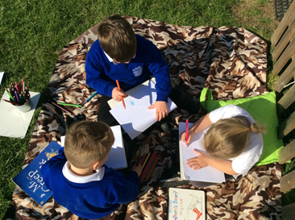
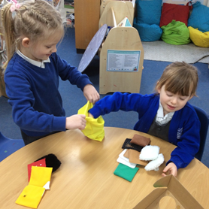
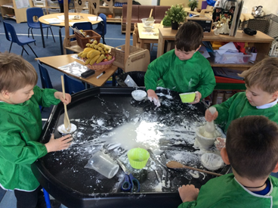

The four specific areas help children to strengthen and apply the prime areas:
Literacy is crucial for children to develop a life-long love of reading. Reading consists of language comprehension (necessary for both reading and writing) and word reading. Language comprehension is developed by talking with children about the world around them and reading a variety of books (stories and non-fiction) including rhymes, poems and songs. Skilled word reading, taught in reception, involves both the speedy working out of the pronunciation of unfamiliar printed words (decoding) and the speedy recognition of familiar printed words. Writing involves transcription (spelling and handwriting) and composition (articulating ideas and structuring them in speech, before writing).
Mathematics is about developing a strong grounding in number, which is essential so that all children develop the necessary building blocks to excel mathematically. We endeavor that by the end of reception, children should be able to count confidently, have developed a deep understanding of numbers to 10 and the relationships between them and the patterns within those numbers. By providing frequent and varied opportunities to build and apply this understanding, children will develop a secure base of knowledge and vocabulary from which mastery of mathematics is built. Rich opportunities will be provided for children to develop positive attitudes and interests in mathematics, look for patterns and relationships, spot connections, ‘have a go’ and not be afraid to make mistakes.
Understanding the World involves guiding children to make sense of their physical world and their community. This includes offering them a variety of personal experiences which increases their knowledge and sense of the world around them, including visiting parks and outings to meeting important members of society such as police officers. In addition, listening to a broad selection of stories, non-fiction, rhymes and poems will foster their understanding of our culturally, socially, technologically and ecologically diverse world.
Expressive Arts and Design development encompasses children’s artistic and cultural awareness and supports their imagination and creativity. We provide regular opportunities for the children to engage with the arts, enabling them to explore and play with a wide range of media and materials. The frequency, repetition and depth of their experiences are fundamental to their progress in interpreting and appreciating what they hear, respond to and observe.

All of these areas of learning are connected together. The characteristics of effective teaching and learning weave through them all. That’s because children in the Early Years are becoming more powerful learners and thinkers. These characteristics develop as they learn to do new things, acquire new skills, develop socially and emotionally, and become better communicators.

Active Learning through Play
‘Play is the work of the child’
At Duxford we understand the importance of play and the motivational force this has on a child’s learning process. Active Learning is the natural way children learn about their environment and develop their own capabilities. It enables them to exercise their imagination and extend their physical abilities, try out new ideas and problem solve. Through active learning children develop social relationships, language, a sense of achievement and increased self-esteem.

Buddies
In order for our Reception children to feel secure when they join Duxford Primary School, they are allocated a Year 6 ‘buddy’. Thus, they immediately have a friendly, helpful and sympathetic face showing them where everything and everybody lives and guiding them through the break and lunch periods. Children also become members of a House Group – Lancasters, Spitfires, Hurricanes or Concordes. The children take part in many varied activities throughout the year in their House Groups.

Outdoor Learning
At Duxford, we strongly believe in the value of outdoor learning, which is now, a key element of our curriculum and learning across the whole school. Learning outside the classroom supports the development of healthy and active lifestyles by offering children opportunities for physical activity, freedom and movement, and promoting a sense of well-being as well as to inspire the children and to reconnect them with nature.

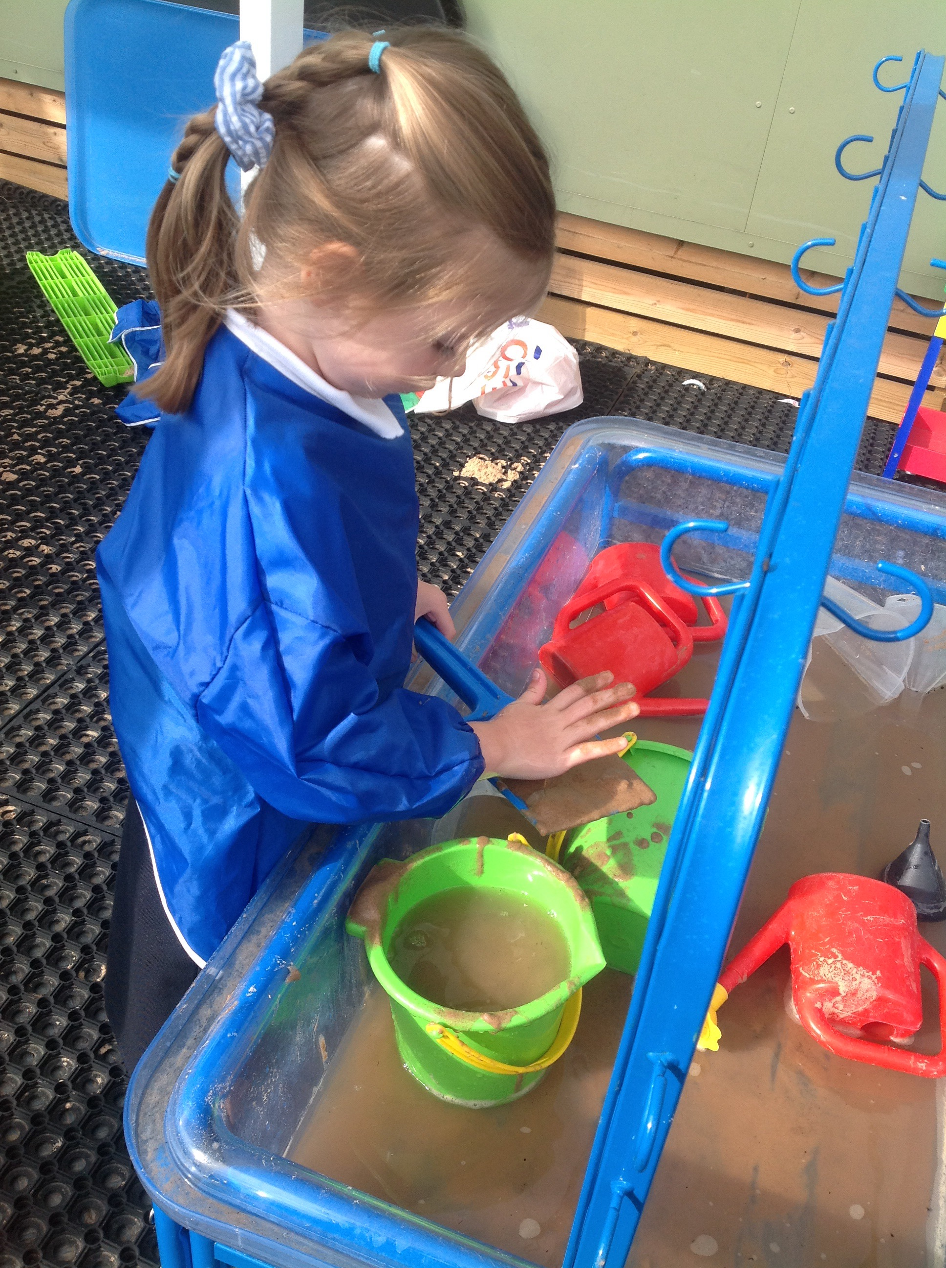
We timetable outdoor lessons into groups, which may cover lessons such as science or geography but also art, music, design, history, reading, writing and maths etc.

In addition, Reception children are encouraged to use their outdoor space for exploration/learning, to be physically active and have supervised ‘free flow’ access into the Reception garden. It is vital that each child brings in a pair of wellington boots and has a sensible coat each day as they use the outdoor spaces in all weathers.

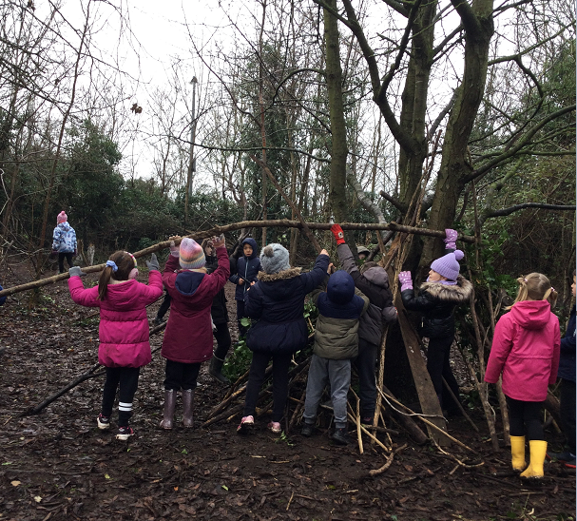
Treetops - a Forest School experience
Treetops aims to allow children time to reflect and explore feelings, thoughts and relationships, developing an understanding of the world and the environment around them along with recognising emotions, imagination and senses. Sessions are led by Mrs Barnard, who is trained to plan and teach Treetops, Forest School experience. Sessions take place in our onsite wildlife area.

Please ensure that your child wears clothes that cover their arms and legs during these sessions.

ENJOYING BOOKS AT HOME AND AT SCHOOL
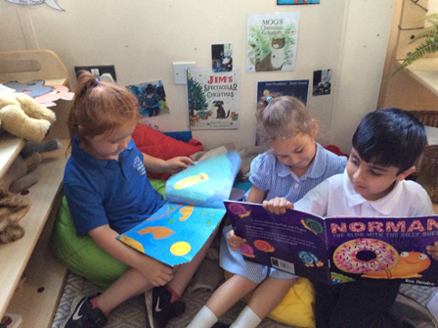
Can you explain the scheme for reading books in Reception and Key Stage 1?
In Reception, shortly after starting school, the children will be able to choose a story book to share at home before moving onto books with no text. This all helps with pre-reading skills which is a vital part of learning to read. After October half term, the children will begin to be taught to read sounds and words and will come home with books to help them develop their segmenting and blending skills. Each child will be listened to read at least once per week by an adult in school.

In the first few weeks of school, your child’s reading ability will be assessed and, when appropriate, they will be given a reading book to bring home. After the children have settled in, you will be invited to a reading meeting where the method used to teach reading is explained, including how best to support your child.

At Duxford we use Twinkl Rhino reading books which align with our Twinkl phonics scheme. Teachers assess children at the end of each phonics teaching sequence. These assessments are then used to decide which level of book the children receive. Children have their Rhino reading book changed once per week to ensure that children are fluent with their reading. Please see our Rhino reading guide for more information about how to use our reading books.

Children will also bring home a reading for pleasure picture book which they can change as often as they like and share with their families. Children are not expected to read these by themselves.

How is reading taught in Key Stage 1 and Key Stage 2?
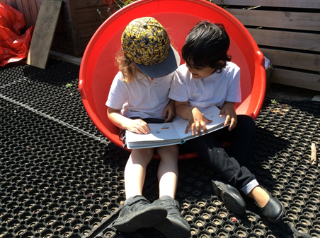
At Key Stage 1 children have reading built into many of their lessons. Children also take part in guided reading lessons across each week. In these sessions, the class will share a book with their teacher and complete activities and take part in discussions which will build on their comprehensions skills.
At Key Stage 2, children also take part in daily guided reading sessions. During these lessons, children read a whole class text, chosen by the class teacher and complete activities to support their understanding. Using the text, children are taught unfamiliar vocabulary, comprehension and prediction skills. If children require additional support with their reading, they read with an adult on a regular basis.
All children are encouraged to have a home reading book to read for pleasure. We encourage you as parents/carers to support your child to read or listen to audio books. Remember the more your child reads or listens to stories, the better a writer they will become!

Collective Worship
‘Collective worship strengthens relationships by bringing pupils and staff together. Effective partnerships with the church enriches worship for the wider community. ‘ SIAMs inspection May 2024
The children attend a daily act of collective worship and each week these are led by:
The local rector
Various members of the local Christian churches
The headteacher
Class teachers
Pupil collective worship group
There is a weekly ‘Celebration’ assembly at which special cards are presented, house point results are announced and any achievements of individuals or teams are celebrated. Every child who has had a birthday is invited to share and ‘Happy Birthday’ is sung.

Assemblies are underpinned by Christian values and also include stories and reflections from other cultures and religions. Throughout the year there are special celebrations for Harvest Festival, Christmas, and Easter where we attend St Peter’s Church. The last assembly of the year is very special as it is led by the Year 6 leavers and celebrates their time at Duxford.
Parents may withdraw their children from collective worship and/or Religious Education lessons. If you choose to do so, please send a written request to the Headteacher.
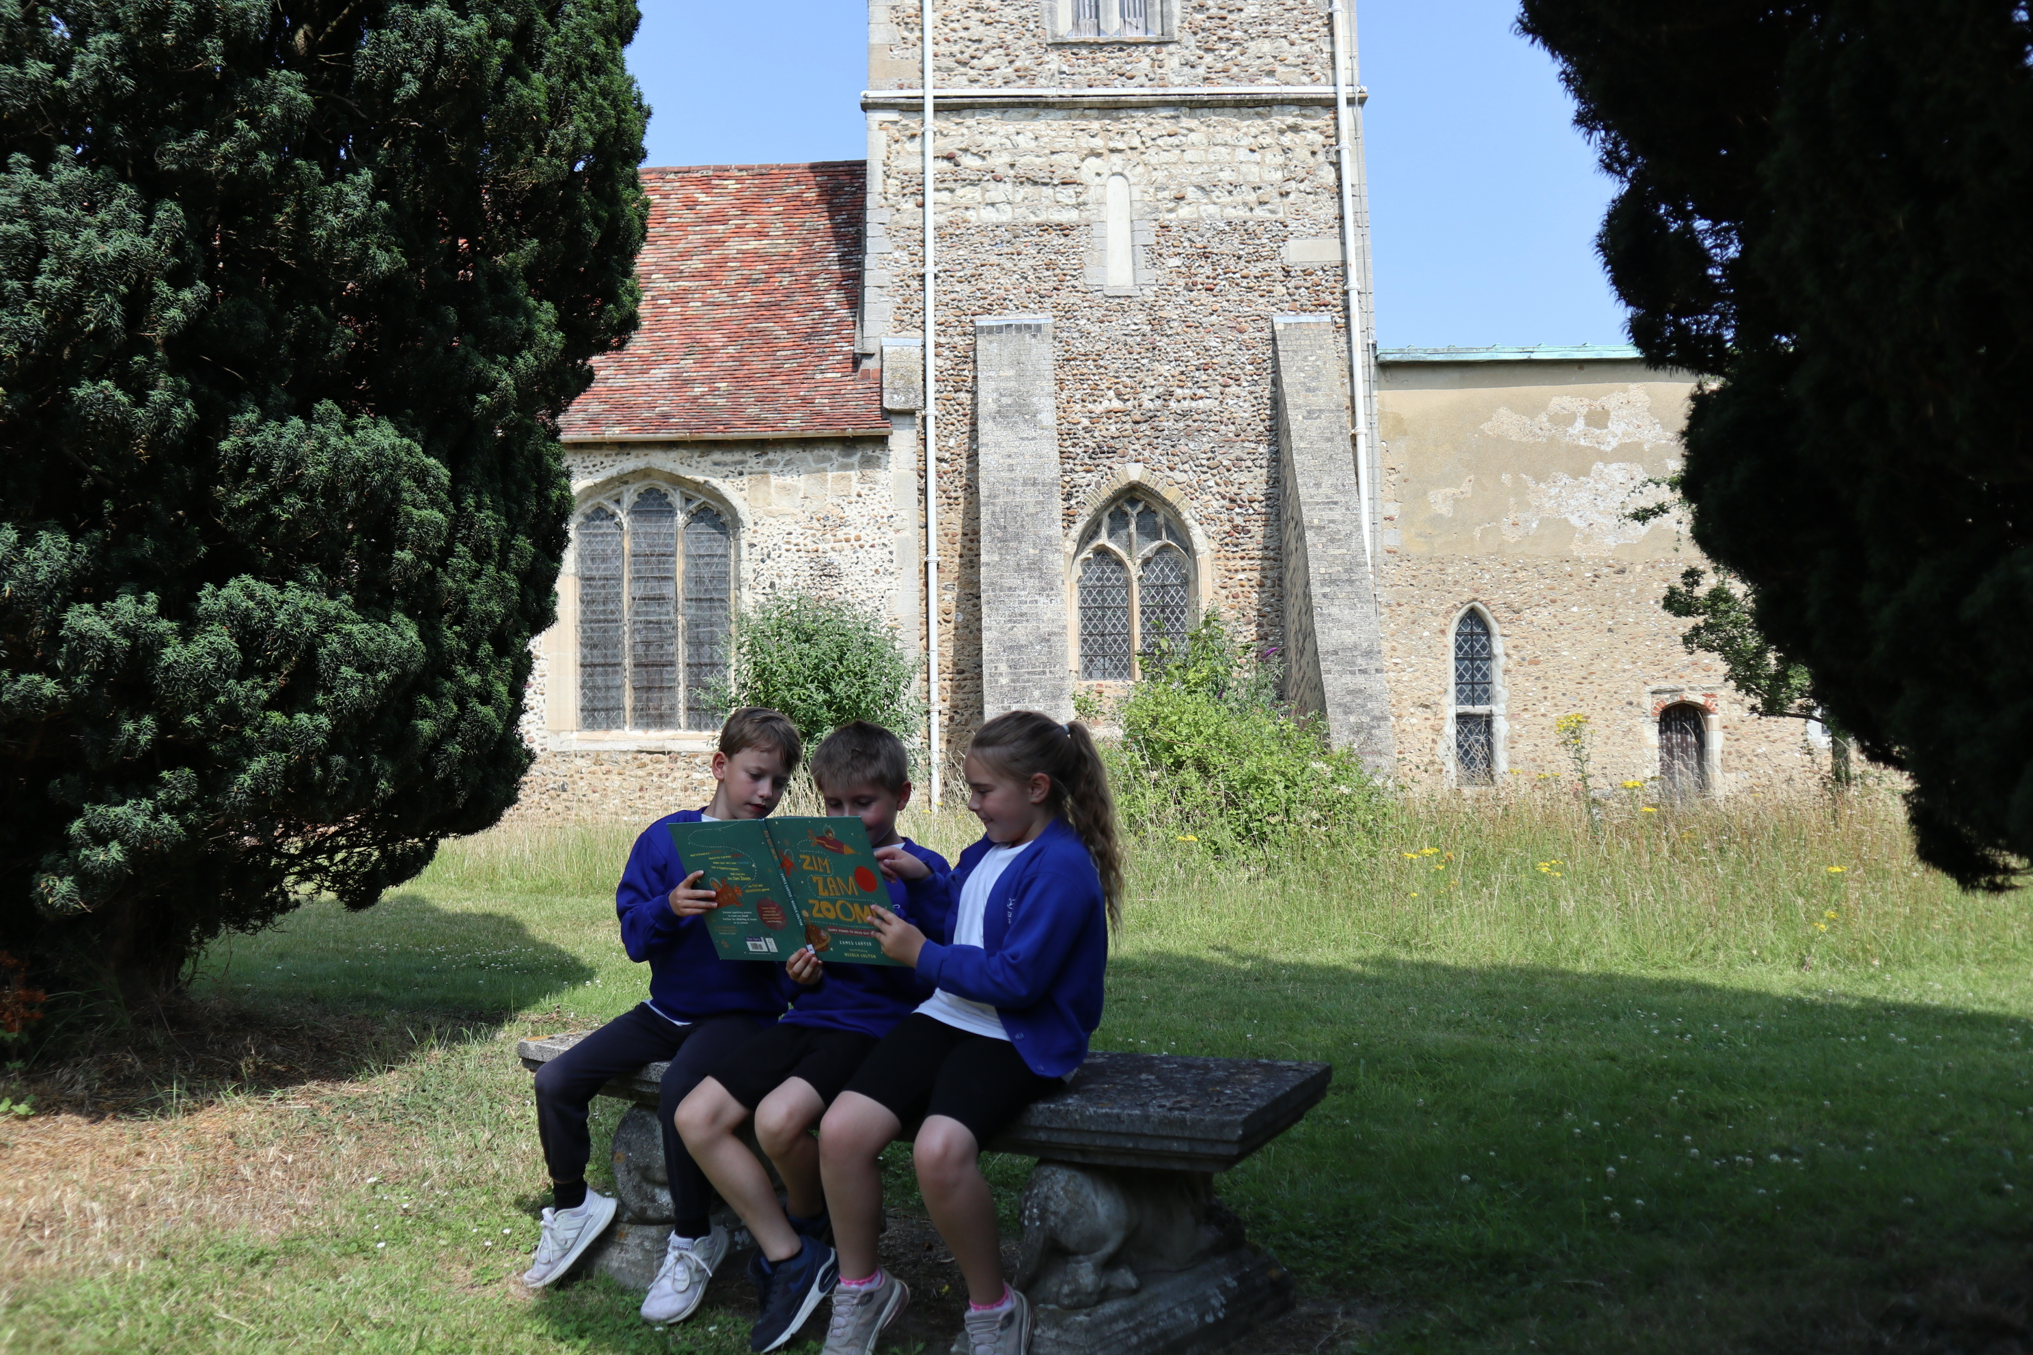

SCHOOL CLOTHING AND PROPERTY
The school feels that it is important that the children look smart and feel part of a team. This all contributes to the ethos of the school and helps set an appropriate tone. For full details, see our Uniform Policy on our website.
Uniform
The following items, with the school logo, are available via our online shop http://www.brigade.uk.com
White or Blue Polo Shirt (These can also be purchased from supermarkets or clothes shops without the school logo)
Blue Sweatshirt or Cardigan (We request that all children wear a school sweatshirt or cardigan with the school logo)
Book Bags
Year 6 only - Maroon Sweatshirt or Cardigan

Grey/black trousers, skirts or pinafores can be bought from most retailers. In summer shorts and blue gingham dresses are acceptable (no leggings underneath skirts or dresses please). In the winter (again no leggings) thick tights can be worn under skirts or pinafores. Tights should be either, white, grey, black or navy blue.
Children should wear appropriate black shoes (no trainers please) to school which are safe for class and playtime activities. Name all items of clothing and check regularly to ensure the name is still visible.
In the interests of safety only one pair of small stud earrings may be worn in school. These must be removed by the child before PE activities in order to comply with health and safety regulations. If your child is unable to do so please remove them before school. Long hair should be tied back at all times, not just for PE in the interests of safety. No make-up, including temporary tattoos, dyed hair or nail varnish is to be worn.

PE and Games Kit
Class teachers will inform parents of the days that PE lessons will take place and children should come to wearing their PE kits. Each child is required to wear:
plimsolls or trainers,
shorts, leggings or jogging bottoms (depending on the weather) in plain navy or black
a PE T-shirt with the logo is preferred. For children already enrolled in school, a plain white navy or black t-shirt or polo shirt may be worn.
A school sweatshirt

Lost Property
Please clearly mark all clothing with the name of your child so that it can be returned when lost.
In Key-Stage 1 all items of lost property are kept in the classrooms.
Children’s Personal Property
Valuable items such as jewelry and precious toys, including fitbits, electronic games and mobile phones should not be brought to school because school cannot accept responsibility for any damage to or the loss of children’s property.

CHILD WELFARE
Child Protection
It may be helpful to parents to know that Headteachers are obliged to report any obvious or suspected case of child abuse - which includes non-accidental injury, severe physical neglect, emotional abuse and/or sexual abuse. This procedure is intended to protect children at risk and schools are encouraged to take the attitude that, where there are grounds for suspicion, it is better to be safe than sorry. This does mean that Headteachers risk upsetting some parents by reporting a case which, on investigation, proves unfounded. In such circumstances, it is hoped that parents, appreciating how difficult it is for Headteachers to carry out this delicate responsibility, would accept that the Headteacher was acting in what were believed to be the child’s best interests.

Safeguarding
Under the Education Act 2002 (section 175), schools must “make arrangements to safeguard and promote the welfare of children”.
We will endeavour to provide a safe and welcoming environment where children are respected and valued.
The school will therefore be alert to signs of abuse and neglect and will follow the Safeguarding Children Partnership Board’s procedures to ensure that children receive appropriate and effective support and protection.
Parents/carers should know that the law requires all school staff to pass on information which gives rise to a concern about a child’s welfare, including risk from neglect, physical, emotional or sexual abuse. The school should make parents/carers aware that records of safeguarding concerns may be kept about their child. They should be informed that school staff will seek, in general, to discuss any concerns with them including referrals to other agencies.
Local procedures state that “Consent should always be sought from an adult with parental responsibility for the child/young person before passing information about them to Children’s Social Care, unless seeking consent would place the child at risk of significant harm or may lead to the loss of evidence for example destroying evidence of a crime or influencing a child about a disclosure made.” This includes allowing them to share information without consent, if it is not possible to gain consent, if it cannot be reasonably expected that a professional gains consent, or if to gain consent would place a child at risk.
Where there is a need to share special category personal data, the Data Protection Act 2018 contains ‘safeguarding of children and individuals at risk’ as a processing condition that allows professionals to share information.
In accordance with legislation and local Information Sharing protocols, we will ensure that information is shared securely and sensitively. Information will only be shared with other services where it is deemed necessary and proportionate to ensure that children and young people are safe and receive the right service. In all circumstances, the safety of the child will be the paramount concern.
Schools will contact Children’s Social Care when they have reasonable cause to suspect a child may be suffering or likely to suffer significant harm. Occasionally, concerns are passed on which are later shown to be unfounded. Parents/carers will appreciate that the member of staff in the school with responsibility for child protection (known as the Designated Safeguarding Lead or Deputy Designated Safeguarding Lead) was carrying out their responsibilities in accordance with the law and acting in the best interests of all children.

Keeping school informed
We believe that, by working together, we can best support your child’s academic and emotional wellbeing. If something happens at home that is new or unusual, this can often affect your child in school and it is useful if parents can let class teachers know. For example, the death of a pet, a family illness, separation or divorce etc. If you would prefer to discuss this confidentially with the Headteacher, please make an appointment via the office.

Medicines in School
We are able to administer prescribed medicines such as antibiotics. Please see the Medicines in School policy on our website. Please complete a Medicine Form, available from the school office, if medicine needs to be administered during school time. Inhalers should be kept in the classroom and if possible stay in school at all times. Parents of a child with asthma or a chronic condition should contact the school to discuss the individual needs of the child. Over the counter medicines can only be administered by school if agreed in advance with the Headteacher

Illness
If your child becomes unwell during the school day they will be cared for by a trained first-aider and parents/carers will be contacted and asked to collect their child. Please ensure that school has at least 2 contact names and telephone numbers.
If a child becomes unwell with vomiting or diarrhoea please allow 48 hours to elapse after the symptoms have ceased before returning them to school.

Accidents in School
In the event of an accident, we will act in the manner of a responsible parent. All our teaching assistants are qualified in first aid and, in the event of an accident, they will provide the child with appropriate treatment. We have an online accident reporting system to log any first aid administered to a child and parents will be informed automatically via email.
The school will assess if the parent/carer needs to be called and, in the unusual event of a serious injury, whether an ambulance needs to be called. Every effort will be made to contact the child’s parents or guardians.

Attendance
If your child is registered at a school he/she must by law attend that school regularly and punctually. Your child should only miss school if he/she is ill or unable to attend for some other unavoidable reason.
If your child is absent and school either does not receive an explanation from you, or considers the explanation unsatisfactory, it will record your child’s absence as ‘unauthorised’.
A child becomes of compulsory school age when they reach the age of five. Most absences for acceptable reasons will be authorised by your child’s school such as:
-sickness
-unavoidable medical or dental appointments (if possible, arrange these for after school or during school holidays)
-days of religious observance
Attendance is monitored regularly and we will contact you if attendance drops below 90%.
If you know or think that your child is having difficulties attending school, you should contact the school. It is better to do this sooner rather than later, as most problems can be dealt with very quickly.

Holidays
Government guidelines state that Headteachers may not grant any leave of absence for a family holiday. The expectation of the school and Local Authority is that term time holidays should not be planned or booked as a matter of course as they are unlikely to be authorised and may lead to the issuing of a penalty notice.

Appointments
All dental, doctor and hospital appointments should be made outside of school hours and not in term time. However, if your child has to leave school during lesson time for any reason (e.g. to attend a dental or hospital appointment) please would you put the request in writing and collect your child from the office. We will also require proof of the appointment in the form of an appointment card or text message.

Head lice
Head lice and nits (the eggs of the lice) are a frequently recurring problem in every primary school and the lice are not fussy about which heads they choose to inhabit!
In order to prevent outbreaks of headlice, it is sensible to inspect your child’s hair at least once a week and to encourage them to brush or comb it well twice a day. Washing the hair in a shampoo containing tee tree oil is also thought to prevent nits. Long hair must always be tied back.
Advice on how to deal with head lice is available from a pharmacist. However, many parents find that the most effective method is to apply a very large amount of conditioner to your child’s hair after it has been washed. The conditioner demobilises the lice and nits and should be left on while the hair is ‘wet combed’ using a special ‘nit comb’ to remove the nits/lice from the hair. This process needs to be repeated on a nightly basis until the hair appears to be nit free.

Welfare Support Agencies
The welfare of the child is of paramount importance to the school. We have links with local authority staff such as Educational Psychologists, Social Workers and Health Teams, as well as to the voluntary and independent sectors.
Our Inclusion Co-ordinator (In-co), Mrs Hirst, is available to provide information and confidential advice on a range of issues.

THE NATIONAL CURRICULUM

The Foundation Stage is the framework for children’s learning in nursery or the Reception class. The learning and development skills that most children should have achieved by the end of their first year at school are called the Early Learning Goals. The Foundation Stage is followed by the National Curriculum.

The National Curriculum:
-Sets out the most important knowledge and skills that every child has a right to learn
-Is a framework given to teachers by government, so that all school children are taught in a consistent way
-Gives standards that measure how well children are doing in each subject

The National Curriculum says when subjects must be taught by describing broad ‘Key Stages’ which are blocks of years. Reception refers to our youngest children aged 4-5 years, Key Stage 1 (Years 1 and 2) refers to children aged 5-7 years, Key Stage 2 (Years 3, 4, 5 and 6) to pupils aged 7-11 years.
In all subjects, children will have the opportunity to work individually, in pairs or in groups. Within each key stage, the school decides how to organise the teaching as they think best. The teachers create their own plans, term by term and year by year. Within the key stages, the children will be working at different levels depending on their ability. The teachers adapt their work so that it is appropriate to the different levels of ability found in each class. Not all children progress at the same rate.
At Duxford Primary School, our aim is to deliver quality teaching and learning for all our pupils through the guidance of the National Curriculum. Learning will involve the linking together of a number of subjects within a single topic or theme each term and so will be cross-curricular. Although cross-curricular links are sought across all planned learning, some learning focuses on discrete subjects.

Further information about our curriculum can be found on the school website.

Keeping school informed
We believe that, by working together, we can best support your child’s academic and emotional wellbeing. If something happens at home that is new or unusual, this can often affect your child in school and it is useful if parents can let class teachers know. For example, the death of a pet, a family illness, separation or divorce etc. If you would prefer to discuss this confidentially with the Headteacher, please make an appointment via the office.

Medicines in School
We are able to administer prescribed medicines such as antibiotics. Please see the Medicines in School policy on our website. Please complete a Medicine Form, available from the school office, if medicine needs to be administered during school time. Inhalers should be kept in the classroom and if possible stay in school at all times. Parents of a child with asthma or a chronic condition should contact the school to discuss the individual needs of the child. Over the counter medicines can only be administered by school if agreed in advance with the Headteacher

Illness
If your child becomes unwell during the school day they will be cared for by a trained first-aider and parents/carers will be contacted and asked to collect their child. Please ensure that school has at least 2 contact names and telephone numbers.
If a child becomes unwell with vomiting or diarrhoea please allow 48 hours to elapse after the symptoms have ceased before returning them to school.

Accidents in School
In the event of an accident, we will act in the manner of a responsible parent. All our teaching assistants are qualified in first aid and, in the event of an accident, they will provide the child with appropriate treatment. An accident slip will be sent home with your child detailing the injury and any first aid given. A call will always be made for a head injury.
The school will assess if the parent/carer needs to be called and, in the unusual event of a serious injury, whether an ambulance needs to be called. Every effort will be made to contact the child’s parents or guardians.

The Daily Mile
During April 2018, we installed a ‘Daily Mile’ track around our school field, linking the playgrounds of Key Stage 1 and Key Stage 2. The track is approximately a quarter of a mile in length. Using the track is a social activity, where the children run or jog – at their own pace – in the fresh air with friends. Children can walk to catch their breath, if necessary, but aim to run or jog for 10 - 15 minutes.
The aim of The Daily Mile is to improve the physical, social, emotional and mental health and wellbeing of our children – regardless of age, ability or personal circumstances. Its aim is to make a positive impact on not only the children’s fitness, but also their concentration levels, mood, behaviour and general wellbeing.

FRIENDS OF DUXFORD SCHOOL
The FODS provides a vital link between the school, parents and the wider community and raises a significant amount of money to provide extra facilities for the school. Committee meetings are held once every six to eight weeks according to need. Meetings are normally held at the school. New members are always welcome. If you would like to be involved in the Committee look for the list of office holders on the FODS Noticeboard adjacent to the Main Entrance to the school and make contact with the Chair or Secretary.
If you cannot afford the time to be on the Committee but would like to help, there are many other ways to make a contribution. FODS have raised money by asking for donations to park in school and selling food to people who wished to watch the Air Days at the Imperial War Museum from outside the airfield. Volunteers ran the car park, the BBQ and the café and baked cakes and biscuits to sell. We hope that this will resume soon.
Advance notice is given in “Airwaves”, the weekly school newsletter. Help in running the annual Summer Fete is always appreciated as is family involvement in the Christmas Fayre in December.
Check both “Airwaves” and the FODS noticeboard for upcoming events and make the effort to become involved. It is a great way to help the school, your children and to meet other parents. You will be almost guaranteed to find fun and friendship along the way.

THE GOVERNING BODY
The governing body consists of twelve governors, representing parents, staff, the local community, the Church of England and the Local Education Authority. The school governors help to provide a strategic view for the school in forming policy and in delivering high standards for every pupil in a caring environment.
Details of the current governing body can be found in the foyer. And on the website .
http://www.duxford.cambs.sch.uk
The parent governors are always happy to talk to other parents who may have concerns or comments.

EXTRA CURRICULAR ACTIVITIES DURING THE SCHOOL YEAR

Clubs and Sport
Duxford School offers a great choice of lunchtime and after school clubs for your child to enjoy at different times throughout the year. Some of them are offered to particular year groups.
TheatreKIdz Gymnastics Chess
Multi sports French

THE DX CLUB - BREAKFAST AND AFTERSCHOOL CLUB

Duxford Primary School has a hugely successful before and after school club and a holiday club called The DX Club.The DX Club is a managed by voluntary trustees of parents of children who attend Duxford Primary School. The DX Club is charity organization and is also registered with Ofsted and in their last inspection received an overall Outstanding rating.

Working parents can take advantage of any of the clubs, where children want to be!

Children can be dropped off at 7.45am and have breakfast before school, children can attend the Afterschool club straight from school until 6pm or children can attend any of our holiday clubs from 9am to 5pm.

The DX Club uses an online registration and booking system called MagicBooking: Dashboard - The DX Club (magicbooking.co.uk)
https://thedxclub.magicbooking.co.uk/Account/Login
thedxclub@hotmail.co.uk

Instrument Tuition
The school works in collaboration with Cambridgeshire County Council to provide music tuition on site to students through Cambridgeshire Music.
Tuition is available (depending on demand) for:
Recorder, Flute, Clarinet, Oboe, Trumpet, Cornet, Trombone, French Horn, Baritone, Tuba ,Violin, Viola, Cello, Double Bass ,Percussion, Drum Kit,Piano, Keyboard ,Guitar, Bass Guitar
More information can be found at:
www.cambridgeshiremusic.org
Music Workshop
Duxford Primary School is fortunate to have close links with Duxford Saturday Workshop (a music and drama workshop offering many different musical opportunities). This is a fantastic group which is open to all adults and children from the age of five years. Should you wish to find out more detail, the workshop has a very informative website at:
www.duxfordsaturdayworkshop.org.uk
Annual registration for the workshop occurs on a Saturday in September. The process for joining is to go along to the workshop to discuss your musical or dramatic area of interest. You will be asked to fill out a registration form which can be found on the website.
The Workshop is fortunate to have a good stock of musical instruments for members to borrow for a small fee. Whilst membership is open throughout the year, those joining after the September registration day may be limited in choice.

Active Travel
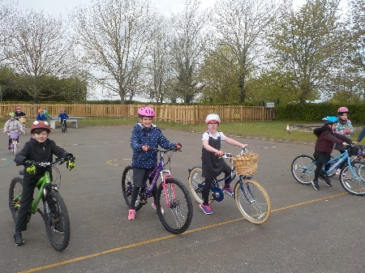
At Duxford CofE Community Primary School, we have achieved green accreditation for our travel plan and we encourage pupils and adults to walk, scoot or cycle to school as often as possible. Eco Group are working hard to encourage everyone to walk, cycle, scoot or use the school bus to come to school. Every year many classes have Bikeability training to give children the skills and confidence they need to cycle safely. This starts with balance bikes in Reception up to cycling on the road in Year 6.
Being active helps us to stay healthy and also helps the environment. Please do all you can to enable your child to travel to school in a healthy way.

STAFF 2025/2026
Miss Sarah Medley Co Headteacher, Designated Safeguarding Lead, Senior Leadership Team,
Mrs Laura Johnston Co Headteacher, Deputy Designated Safeguarding Lead, Senior Leadership Team,
Mrs Jessica Shevki Class teacher, staff governor, Deputy headteacher
Lianne Lawrence Class teacher
Mr Jonathon Yarde-Leavett Class teacher
Miss Emma Barron Class teacher
Mrs Rebekah Yeo Class teacher
Mrs Victoria Hirst Inclusion Co-Ordinator (In-co), Deputy Designated Safeguarding Lead, part-time
Mrs Andrea Barnard TA part time, HLTA, governor
Mrs Victoria Baker-Grigg TA part time
Mrs Lucia Kolarik TA
Mrs Karen Ranasinghe TA part time
Miss Danielle Millar-Rednall TA part time
Mrs Sarah Herring TA part time
Mrs Caron Bates TA part-time
Ms Joanne Vincent TA part time
Mrs Larissa Griggs TA part time
Miss Amy Woor TA part time
Mrs Victoria Roper Business Manager, Senior Leadership Team, part-time
Mrs Vicky Rigby Reception Office Administrator, part time
Mrs Sarah Cahill Finance assistant, part time
Mr Lionel Beard Site Officer, ICT technician
Miss Joanne Bishop School Caterer
Mrs Hannah Farmer School catering assistant
Mrs Diane Dellar Cleaner
Miss Vanessa Cann Cleaner
Mrs Diane Poulter Cleaner

EDUCATION JARGON BUSTER

School life brings many abbreviations and educational jargon. We have tried to cover everything you may hear, but new words and acronyms appear all the time, so please ask if you hear something new!
Computing | Computing (formerly known as ICT) is the teaching and learning of computer skills and software.
Early Learning Goals | These set out the learning and development skills most children should have achieved by the end of their first year at school.
Early Years Foundation Stage | Often shortened to EYFS, this is the set of standards for the learning, development and care of children from birththe end of their first year at school.
Guided Reading | Children work as a class or in small groups to read and discuss a text.
PTD, INSET or closure days. | In-Service Education and Training. Inset days are set aside to allow teachers time to update their skills and knowledge in order to raise pupil achievement. There are five days a year which are usually held at the start of term or either side of a half term. They are decided locally by each school and published annually and are sometimes referred to as Baker days, or PTD)
LA | The Local Authority is the body responsible for providing education for pupils of school age in its area.
National Curriculum | The basic framework setting out what children aged 5 to 16 in state schools should learn.
OFSTED | Office for Standards in Education. The body which inspects state-funded schools. OFSTED inspectors produce education reports to help improve standards.
PPA Time | Teachers’ planning, preparation and assessment time.
PSHE | Personal, social and health education
SATs | Standard Assessment Tests. These are the national tests that children take at the end of Key Stage 2 (Year 6).
SEND | Special Educational Needs and Disabilities. Learning difficulties for which a child needs additional support.
SIAMS | Statutory Inspection of Anglican and Methodist Schools

For Further Information contact:

Duxford C of E Community Primary School
St Johns Street
Duxford
Cambridgeshire
CB22 4RA
Telephone:
01223 712108
Office@duxford.cambs.sch.uk
Website: www.duxford.cambs.sch.uk

22

