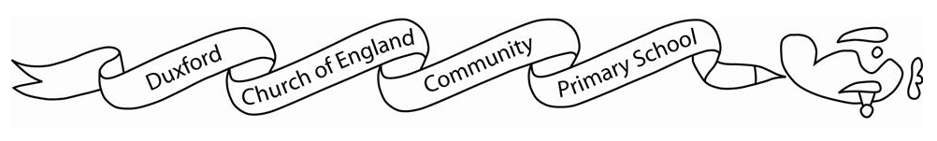
Starling class Curriculum Grid:
 | Spring 1 | Spring 2
English | Text: Snail and the whale by Julia Donaldson.  Outcome: Letter  Text: Rapunzel by Bethan Woollvin  Outcome: Descriptive writing diary entry | Text: Monsters: An Owner’s Guide by Jonathan Emmett & Mark Oliver.  Outcome: Explanation Text  Trip recount
Maths | Year 1:  Place value (within 20)  Addition and subtraction (within 20)  Place value (within 50)  Year 2:  Money  Multiplication and division | Year 1:  Place value (within 50)  Length and height  Mass and volume  Year 2:  Multiplication and division  Length and height  Mass, capacity and temperature
History |  | What were nurses like in the past?
Geography | What is it like to live in Shanghai?
Science | Year 1:  Invertors  Year 2:  Biodiversity- minibeasts | Year 1:  Plants  Year 2:  Plants and seasons
Art / DT | Art- Colour chaos  Colour mixing and researching how various artists used colour in their work. | DT- Mechanism  Fairground Wheels
Computing | Photography | Programming
PE | Fundamental skills | Movement skills
PSHE | Family and friends | Financial capability
RE | How do some Muslims show Allah is compassionate and merciful? | Why does Easter matter to Christians (Digging Deeper)?
Music | I wanna play in a band | Zootime

