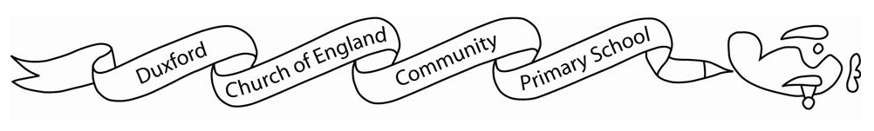

**Home learning Spring 2**

It is *expected* that the following home learning will be completed each week:

**Reading:** Please listen to your child read. Books are changed every Thursday. Please note that we only change books once children can read them fluently (without sounding out). Please write in your child’s reading record if they are reading fluently or are still sounding out. For Year 3 children, we expect them to read for at least 30 minutes a week.

**Maths:**

Children are expected to access Times Tables Rockstars for 30 minutes a week.

**Additional resources:**

If you would like further additional resources to support your children at home, then please contact me through the office.

**The Topic home learning below is optional:**

In Topic, this half term we will be learning all about the world and its different countries and continents. Children can find and research about one country of their choice and create a piece of work (this could be art, a poster etc.).