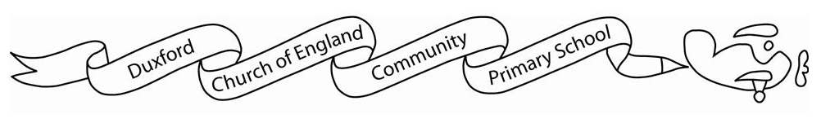
Home learning Spring

It is expected that the following home learning will be completed each week:

Reading:
Children are expected to read at home. Books are available to borrow from the classroom library. Reading aloud to an adult is strongly encouraged.

Spelling:
Children can access and practise their spellings on Spelling Shed.

Maths:
Children are expected to access Timetables Rockstars for 30 minutes a week.

Additional resources:
There are lots of additional resources and websites that you can access on Starz which will support your child’s learning.

The DT/ PSHE home learning below is optional:

This half term, to tie in with our cooking (DT) and Healthy Lifestyles (PSHE) units, I would like the children to come up with a recipe for a balanced meal. This could include a recount of how they came up with the recipe and why they added what they did, and/or an illustrated recipe for others in class to try! As a bonus they could include a photo of their created dish or them trying it.

