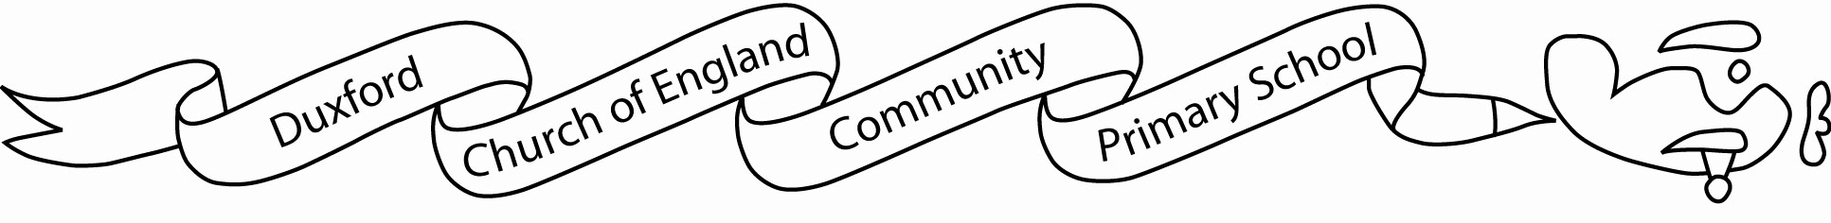
Thursday 11th September 2025
RE: Year 6 residential

Dear Parent or Guardian,
We have arranged to take Year 6 on a residential activity course to PGL, Caythorpe Hall in Lincolnshire from Monday 15th June to Wednesday 17th June 2026.
Residential courses organised by schools are becoming increasingly invaluable as part of the National Curriculum. Indeed, the Government has placed on record the beneficial effects on a child’s progress that such courses provide. They offer new and exciting challenges and by living with their peers and working together in a team environment, help develop independence, confidence and an ability to recognise strengths and weaknesses in a constructive way.
The value of giving children the opportunity to try out new activities cannot be underestimated. No matter your child’s experience and confidence level, everyone learns to develop their independence, growth mindset, to respect and value each other’s ability and their own and to have fun!
At PGL, fully-trained and qualified instructors, with the support of school staff, provide instruction in a full programme of activities in a safe, controlled and secure environment. The activities available include: Climbing, Abseiling, Archery Tag, High Ropes, Orienteering, Raft Building, Overnight Camps, and many more. The activities that Year 6 will do will be confirmed nearer to the time of the residential.
In line with Dfe and school policy, all payments towards this educational visit are voluntary. It is not compulsory for students to take part in the visit but the experience will enhance their learning opportunities, Pupils will not be excluded from any activity for financial reasons. However, if we do not receive enough voluntary contributions, it may be necessary to cancel the trip. This decision will be made on receipt of all confirmation slips. If you would like to discuss this aspect of the trip further, please contact Mrs Roper, School Business Manager.

The total cost of this trip will be £352. To confirm your child’s place, you will need to pay a non-refundable deposit of £50 by 30th September 2025. We would prefer payments to be made via Parentpay. Please do not send cash in with your child. It is possible through parentpay to pay in instalments to suit your budget. The rest of the parentpay payment schedule is broken down into 6 monthly minimum instalments also payable on 30th of each month. If you would like to discuss the payment process with school, please make an appointment with the office.
As per our behaviour policy students who persistently display detrimental or anti-social behaviours in school may be excluded from participating in this school trip or need to be accompanied by a parent/guardian. This is to ensure the safety, well-being and enjoyment of all pupils and staff. Children with SEND may require additional adaptations in order to be successful and safe on the trip; this will be planned for accordingly nearer the time with Mrs Hirst.

For further information about the trip, the activities, the centre etc. please check the website: www.manoradventure.com and you will be able to see for yourself how worthwhile and enjoyable these visits are.
Yours sincerely,
Mrs L Lawrence and Mrs S Stick

 - - - - - - - - - - - - - - - - - - - - - - - - - - - - - - - - - - - - - - - - - - - - - - - - - - - - - - - - - - - - - - - - - - - -
Actions:
The online permission slip and deposit must be completed by Tuesday 30th September.

I give my consent for my child to take part in the visit to PGL Caythorpe Hall in Lincolnshire from Monday 15th June to Wednesday 17th June 2026.
I confirm that I will pay for the total cost of £352 for the residential activity visit and will pay a £50 deposit by 30th September 2025. I understand that the deposit is not refundable once my child’s place has been confirmed.

