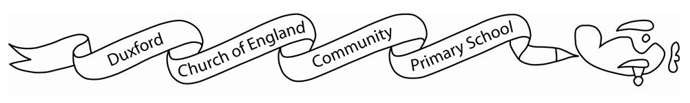
OWL Class Curriculum Grid
SPRING TERM 2024
 | Spring 1 | Spring 2
English | Text:  Traditional Tales  (Ulf and the Finger Eater by Dick King-Smith)  Outcome:  Next chapter/ Alternative version of a traditional tale  Text:  The Bear and The Piano by David Litchfield  Outcome:  Diary Entry | Text:  Various Genres  Outcome:  Letters, Instructions, Do’s and Don’t Poster  Text:  Poetry (The Magic Box by Kit Wright)  Outcome:  Poem (Free verse)
Maths | Yr 2: Money; Multiplication and Division; Length and Height; Mass, Capacity and Temperature  Yr 3: Multiplication and Division (B); Length and Perimeter; Fractions (A), Mass and Capacity
History |  | What was life like in The Shang Dynasty period?
Geography | Rivers (including the water cycle)  Physical geography, including: rivers, mountains, and the water cycle  How does the water cycle work?
Science | Yr 2: Biodiversity- minibeasts  Yr 3: Rocks | Yr 2: Plants and seasons  Yr 3: Plants
Art |  | Painting – Colour Chaos
D&T | Mechanism - Fairground Wheels
Computing | Creating Media: Animations | Programming
PE | Inside: Gymnastics  Outside: Invasion games | Inside: Dance  Outside: Invasion games
PSHCE | Family & Friends | Financial Capability
RE | Digging Deeper Salvation  Why does Easter matter to Christians? | Different world religions overview of Islam, Hinduism, Sikhism, Judaism – What do we know?
Music | Glockenspiel- Composing | More Musical Styles
French | Yr 3:  Food Glorious Food  Food  J’aime/ je n’aime pas  Un/une  Adjectives describing colour and size | Yr 3:  Family and Friends  Family  Possessive adjectives mon/ma/mes  French alphabet, spelling names  The house

